Question 3(a)

An appropriate design pattern to be applied in the implementation of the user interface of the Personal Address Book system would be the Command pattern. This design is suitable since the command-line user interface and the processing subsystem are kept apart. Rather than letting the user interface execute each operation directly, every user request is directly modelled as a command object.

Within this system, the UserInterface() receives the input of the user and the request is sent via the Command interface. The various concrete command classes correspond to various operations, i.e. AddContactCommand(), DeleteContactCommand(), SearchContactCommand(), SaveDataCommand() and Load DataCommand(). The request is then sent to the suitable receiver class by each command object.

ContactManager(), ContactFinder() and DataManager() are all classes in this system that are used as receivers. ContactManager() has the add and delete operations, ContactFinder() has the search operations, and DataManager() has the save and load operations. Using the Command pattern, the system will be more modular, simpler to maintain and simpler to extend in case of added commands in the future.
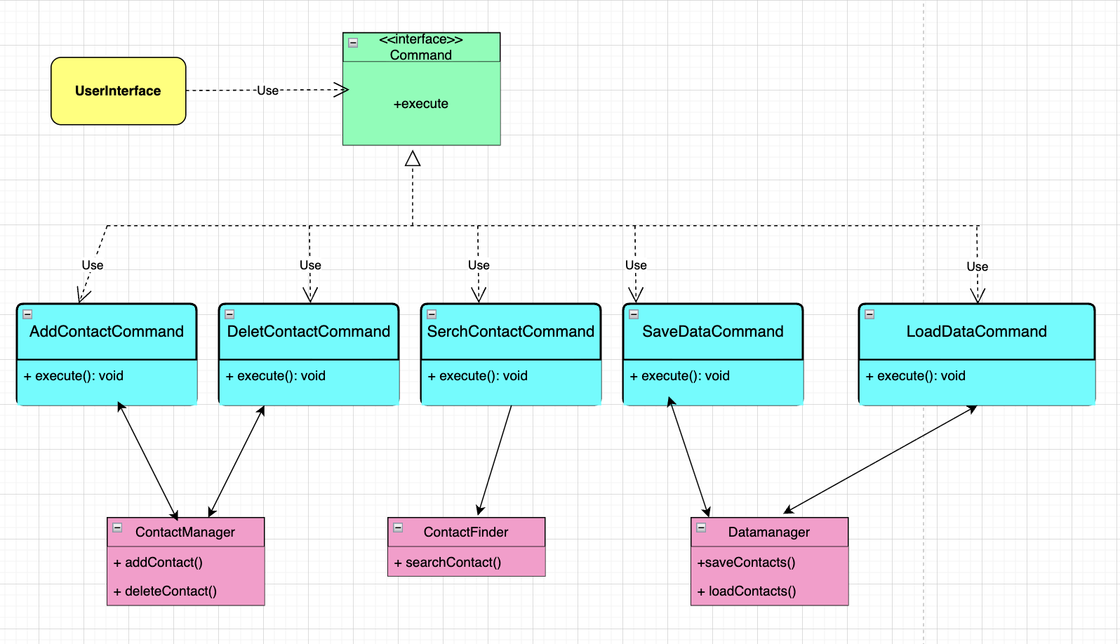

Question 3(b)

This process starts when the user enters a new contact via the command-line interface. The UserInterface() takes the input of the user and generates an AddContactCommand() object. The interface, in its turn, invokes the execute() method of the command.

The AddContactCommand() forwards the request to the ContactManager(), who initiates the addContact() operation as a result of which the new contact is added to the system. Once the contact is added, the ContactManager() sends the contact details to the DataManager() to make the contact information permanent by invoking the saveContact() operation.

Lastly, after the data is made successfully, the confirmation message is sent back to the UserInterface() and the user is made aware that the contact has been added successfully.



